**DSP LAB 2 REPORT**

**Dekun Xie 210337152**

**Introduction**

This lab, I will mainly learn the method of sampling, DFT and downsampling.

**1.** **0 Explain what should be understood by the word “meaningful”, why sample values with index k > N/2 +1 are not meaningful, and why the right hand side shows N/2 + 1 instead of just N/2.**

①’Meaningful’ means if the sample contains the unique information.

②As the former N/2+1 samples contain all information, the samples after N/2+1 carry the same content. Therefore, it’s not meaningful and not useful.

③According to the definition of complex conjugation, after N/2 + 1 the value starts to equal to the former value.

**1.1. Sample a sinusoidal signal with amplitude 1 and frequency of 128 Hz at a sampling rate of 2,048 Hz indexed by 0 <= n <= N -1, where N = 32.** **Plot the result using stem. Include your code and plot in your report.**

1. f = 128;
2. fs = 2048;
3. N = 32;
4. dt = 1/fs;
5. T = (0 : N-1) * dt;
7. x = sin(2 * pi *f * T);
9. stem(0 : N-1, x);
11. axis tight;
12. xlabel('Sample(N)')
13. ylabel('Amplitude')

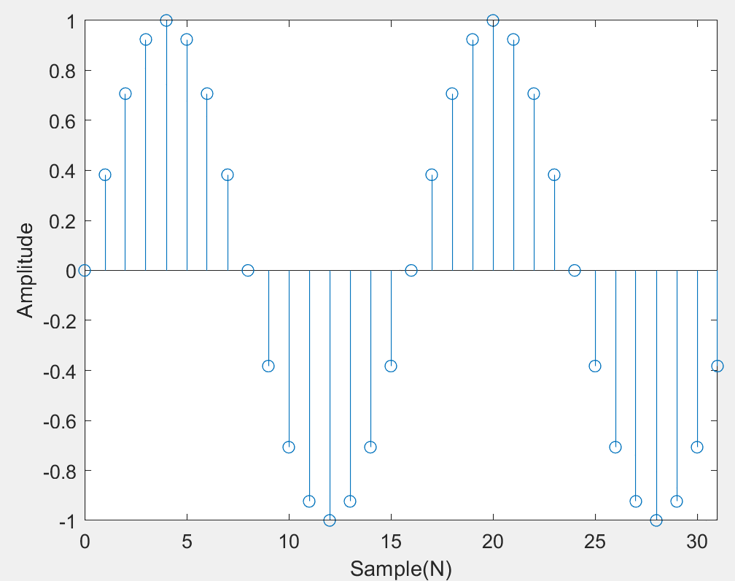

**1.2. Now find the DFT of the sequence you created in 1.1, using the MATLAB routine fft() (just call fft() with the sequence as an argument). Plot the magnitude spectrum of the result, abs(X), versus the corresponding actual frequency (in Hertz and not k). Plot only the frequencies between 0 and Fs/2. Your plot should look like Figure 1. This means using stem instead of plot. Include your code.**

1. f = 128;
2. fs = 2048;
3. N = 32;
4. dt = 1/fs;
5. T = (0 : N-1) * dt;
7. x = sin(2 * pi *f * T);
9. FFT = fft(x);
11. freq_range = [0 : fs / N : fs/2];
13. stem(freq_range, abs(FFT(1: length(freq_range))));
15. axis tight;
16. xlabel('Frequency(Hz)')
17. ylabel('|X|')
18. set(gca, 'xtick', freq_range);

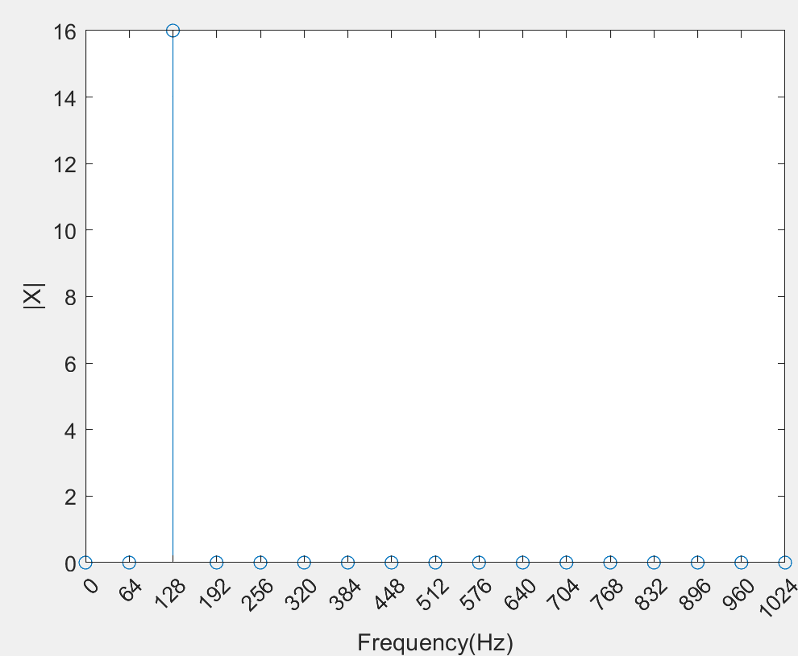

**1.3.What is the phase at 128 Hz? Find this using the angle routine on the relevant value of X[k]. Why does this answer make sense, i.e., explain your reasons how you can get to this result without using MATLAB [Hint: start from the corresponding continuous signal.] What does the sign of the phase tell us?**

1. f = 128;
2. fs = 2048;
3. N = 32;
4. dt = 1/fs;
5. T = (0 : N-1) * dt;
7. x = sin(2 * pi *f * T);
9. FFT = fft(x);
11. ang = angle(FFT);
13. ang_128 =  ang(3) % 128HZ phase

**=>ang_128 = -1.5708**

①Phase is -π/2

②Angle calculates the phase of cosine.

As cos(wt+φ) = sin(wt+φ-π/2), cos(2π*128*t **– π/2**) = sin(2π*128*t)[the signal we process]. Thus, phase φ = -π/2 according to the definition.

③The sign tell us the direction the cosine move. Minus is right.

**1.4.Now sample a sinusoid of 220 Hz at the same sampling rate given in 1.1. Create a 32-sample sequence and plot this versus n using stem. Include the plot in your report, but not your code.**

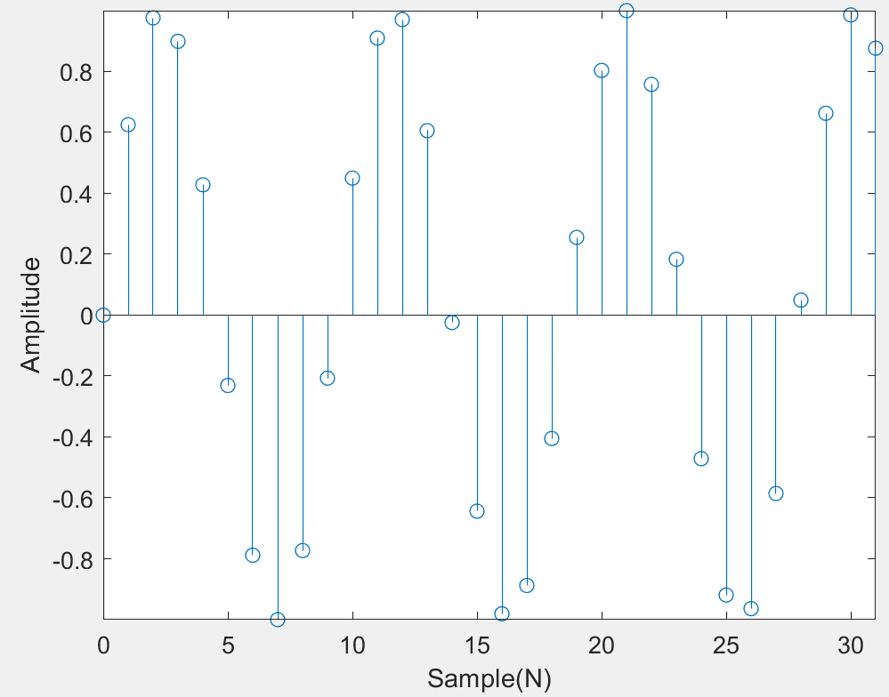

**1.5.** **Draw a picture of what you hypothesize will be the magnitude DFT of this signal. Include in your lab this hypothesized and expected picture. Explain why you drew what you did.**

①Hypothesize

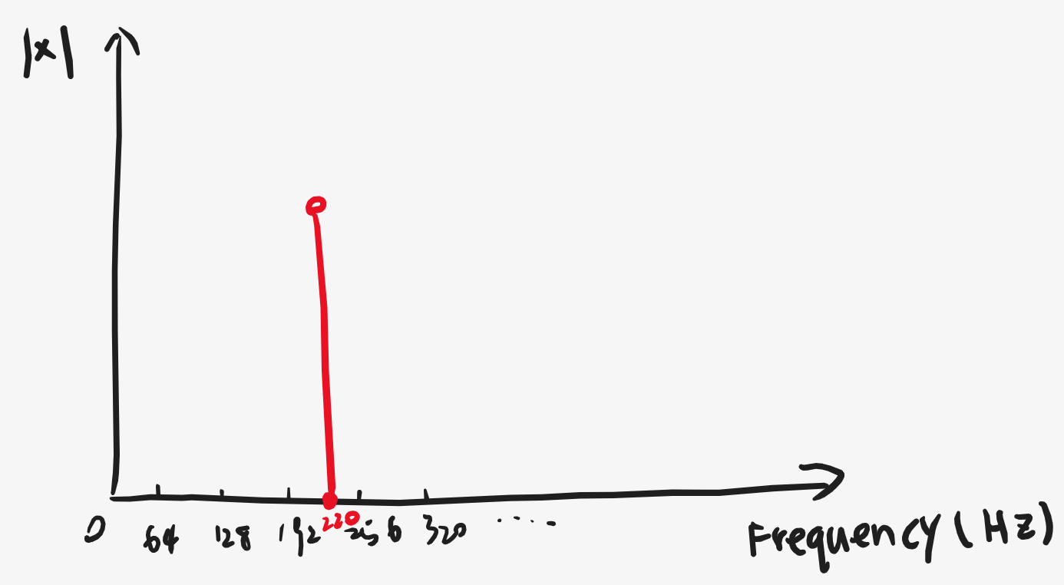

②Explanation: as the frequency of the signal is 220 Hz, generally, the result of DFT is 220 Hz.

**1.6.** **As in 1.2, find the DFT of this signal. Plot the magnitude of the result versus frequency. Include this plot in your report. How does this plot compare to that in 1.2? Was your hypothesized plot, which you created in 1.5, correct?**

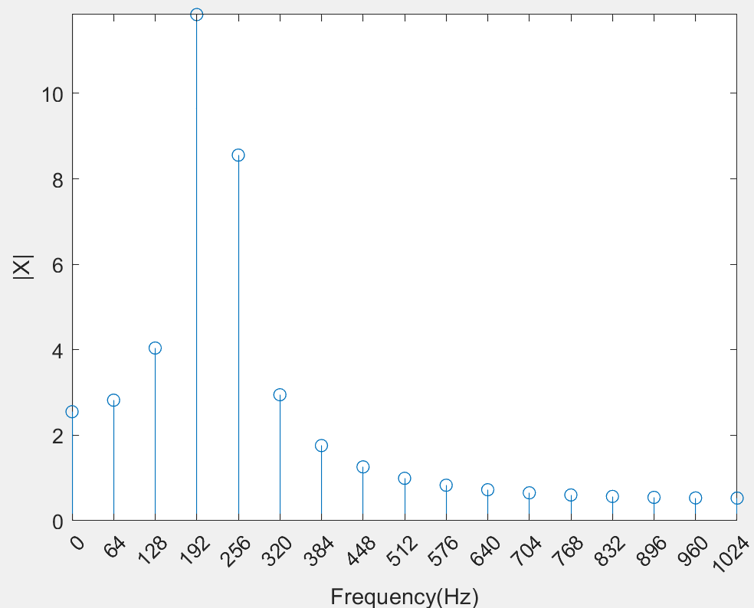

①More frequencies get high magnitude in 1.6 compared with 1.2.

②Hypothesized plot is not correct.

**1.7.Verify that you get the exact same time-domain signal from this spectrum by taking an inverse DFT using the ifft() routine. Plot the resulting timedomain sequence. Is your result real or complex valued? Explain why.**

1. f = 220;
2. fs = 2048;
3. N = 32;
4. dt = 1/fs;
5. T = (0 : N-1) * dt;
7. x = sin(2 * pi *f * T);
9. FFT = fft(x);
11. IFFT = ifft(FFT);
13. stem(0 : N-1 , IFFT);
14. xlabel('Sample(N)')
15. ylabel('Amplitude')
16. axis tight;

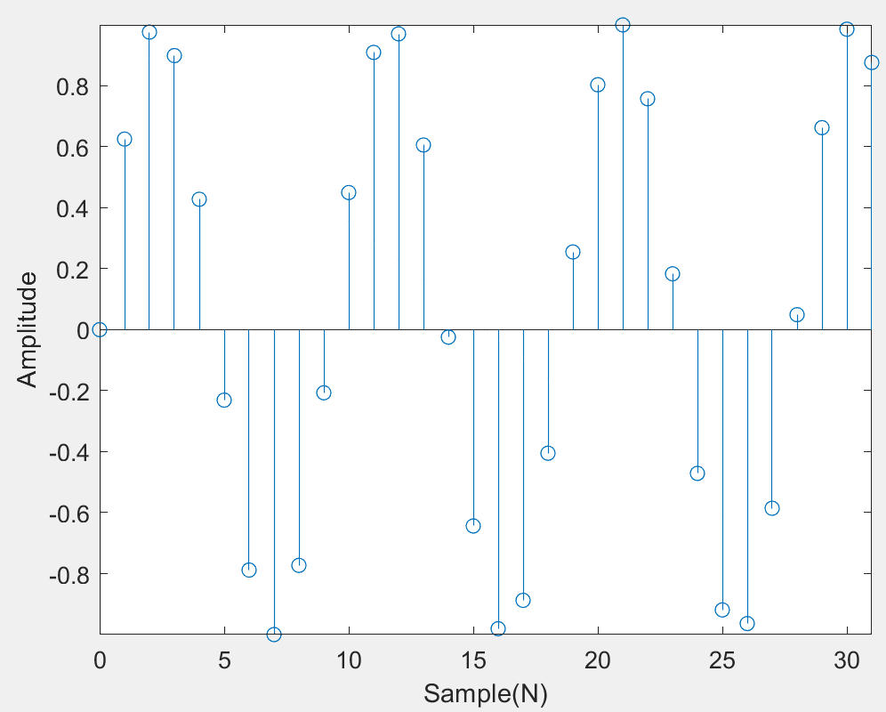

The result is real, as the value in IFFT is real not complex.

**1.8 Create a 512-length sequence of the sinusoid in equation (3) with a frequency of 220 Hz, amplitude of 1, and a sampling rate of 2,048 Hz. As in 1.2, find the DFT of this signal and plot the magnitude of the result versus frequency. Include this plot in your report.**

1. f = 220;
2. fs = 2048;
3. N = 512;
4. dt = 1/fs;
5. T = (0 : N-1) * dt;
7. x = sin(2 * pi *f * T);
9. FFT = fft(x);
11. freq_range = [0 : fs / N : fs/2];
13. stem(freq_range, abs(FFT(1: length(freq_range))));
15. axis tight;
16. xlabel('Frequency(Hz)')
17. ylabel('|X|')

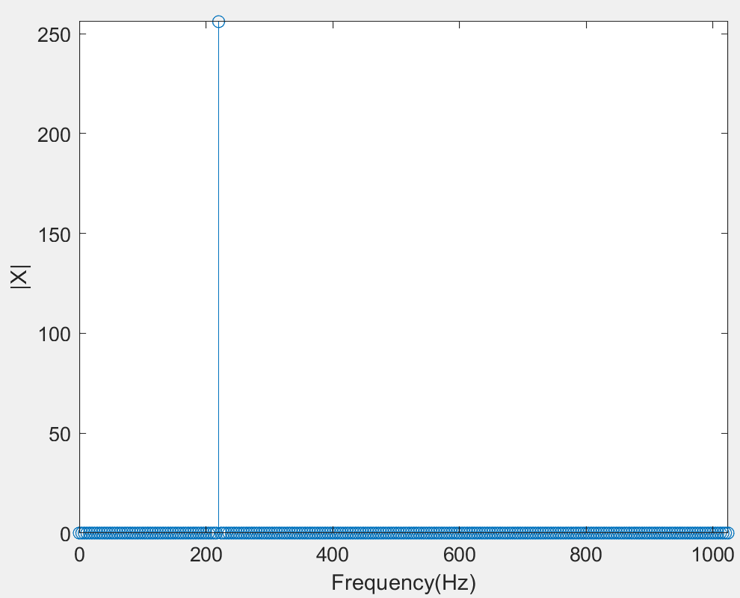

**1.9 Referring back to the plot you made in 1.7, what sample length N would you need in order to show a symmetric discrete spectrum with reference to 220 Hz (i.e., including two maxima of equal height)? Explain your answer.**

N equal to integer multiple of 512(>=512).

Fs / f = 2048 / 220 = 512/55. The nearest integer is 512. So, any integer multiple of 512 can promise the signal contains an integer number of periods to avoid spectral leakage.

2.1 Retrieve from the class website, and load, the speech sound file “speech_female.wav”.

1. clear all
2. sndfile = 'speech_female.wav';
3. [x,Fs] = audioread(sndfile); %read audio files
4. N = 512; % sample number
5. [S,F,T] = spectrogram(x(1:Fs*1.4),N,3*N/4,N*4,Fs);
6. % generate spectrogram parameters **in** first 1.4 s of the audio
7. % S:'estimate of the short-term, time-localized frequency content of x.'
8. % F:'cyclical frequencies'
9. % T:'time'
10. f = figure('Position',[500 300 700 500],'MenuBar','none', ...
11. 'Units','Normalized'); %create figure
12. set(f,'PaperPosition',[0.25 1.5 8 5]); %set figure
13. axes('FontSize',14); %axis setting
14. colormap('jet'); % color setting
15. imagesc(T,F./1000,20*log10(abs(S))); % show image
16. axis xy;
17. set(gca,'YTick',[0:2000:Fs/2]./1000,'YTickLabel',[0:2000:Fs/2]./1000); % set range **and** step of x y
18. ylabel('Frequency (kHz)'); % label axis y
19. xlabel('Time (s)');% label axis x
20. **print**(gcf,'-depsc2','p2i1.eps'); % save 'p2il.eps' file
22. %sound(x,Fs) % play audio

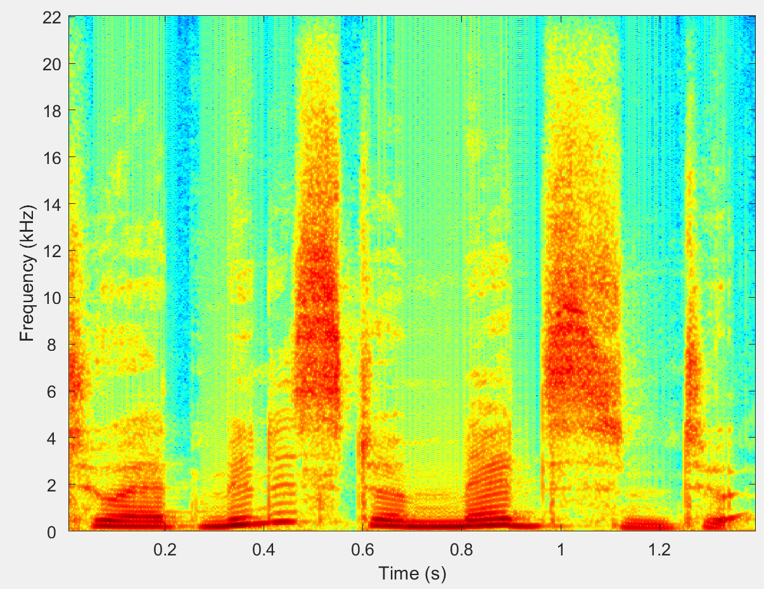

**2.2** **Using the spectrogram you created in 2.1, in what frequency band is most of the energy located? Recalling the Nyquist-Shannon sampling theorem, at what minimum rate would you sample this signal such that it could be reconstructed well? Explain why is this now not an exact reconstruction?**

①Most of energy is located between 0 and 18 kHz

②Minimum sample rate = 22 * 2 = 44 kHz

③As the signal above 18 kHz will alias according to Nyquist sampling theorem.

**2.3 Looking at the distribution of energy across frequencies in your spectrogram, and knowing that the woman says “To administer medicine to a”, which sounds of which words correspond to the energy between 4 and 18 kHz?**

‘To administer medicine to a’. The sounds located between 4 and 18kHz are reded which are voiceless consonants.

**2.4 Looking at the figure you produced in 2.1, what is the highest decimation factor you think that this signal can withstand whilst you can still understand the speech? Explain your reasoning. What would be the sampling rate at that factor? How would you expect the highest decimation rate to change for someone who is unfamiliar with the English language, and why?**

①44100/n >= 2 * 2000

n <= 11.02, n max = 11.

②As the sample below 2 kHz contains most energy expect the effect of voiceless consonant, if the highest 2 kHz can be sampled correctly, the content can be understand. Thus, according to Nyquist theorem., 44100/n >= 2 * 2000 => n <= 11.02, n max = 11.

③fs = 44100/n = 44100/11 ≈ 4009 Hz

④Highest decimation rate will be lower for people who are not familiar with English.

⑤As people who are not familiar with English are easier to fail to understand the English with low quality.

**2.5** **Do it. Include your code. Include all your observations.**

1. clear all
2. sndfile = 'speech_female.wav';
3. [x,Fs] = audioread(sndfile); %read audio files
4. N = 512; % sample number
5. [S,F,T] = spectrogram(x(1:Fs*1.4),N,3*N/4,N*4,Fs);
7. factor = 40;
8. x = decimate(x(1:Fs*5), factor);
10. sound(x,Fs/factor) % play audio

40: sounds unclear and not understandable

38: sounds unclear and not understandable

32: sounds unclear and not understandable

28: sounds unclear and not understandable

25: sounds clearer and kind of understandable

20: sounds clear and understandable

**Conclusion**

By finishing the lab, I learn a lot and there two important point I learn. Firstly, I learn that if set the sample number unproperly, it will cause spectral leakage. Therefore, I should note the way to choose sample number. Secondly, I learn the way to decimate to reduce the information of the sample.